Blogging

02 GDPR, GA

Contents

2 GDPR & cookie consent 1

3 Google analytics 1

3.1 GDPR compilant GA setup 1

3.1.1 Disable data sharing 2

3.1.2 Do not track user by ID 2

3.1.3 Anonymize IP 3

4 Osano – Cookie consent – JS - Itegration 3

# GDPR & cookie consent

GDPR background: <https://www.kevel.co/blog/gdpr-google-analytics/>

Test your site’s GDPR compliance here: <https://2gdpr.com/>

<https://www.cookiepolicygenerator.com/cookie-policy-generator/>

<https://www.privacypolicygenerator.info/>

<https://www.osano.com/cookieconsent/documentation/javascript-api/> - **MIT licensed cookie consent JS**

Tools with analytics:

* <https://www.cookiepro.com/free-signup/> - free up to 100 pages

Simple tools:

* <https://alex-d.github.io/Cookies-EU-banner/>
* <https://github.com/manucaralmo/GlowCookies>
* <https://github.com/Jersyfi/Cookify/wiki>
* <https://www.cookieconsent.com/>
* <https://github.com/cdwharton/cookieCuttr> - old, unmanaged, was used on reflection.sk

# Google analytics

**Important:** localization based on IP, identifying recurring users based on user-ID all require user consent.

## GDPR compilant GA setup

<https://analytics.google.com/>

<https://tagmanager.google.com/>

<https://www.clym.io/articles/how-to-setup-google-analytics-to-be-gdpr-and-ccpa-compliant-in-5-steps>

### Disable data sharing

Inside google analytics, on the admin page, in the account settings tab, **uncheck all checkboxes under data-sharing!**

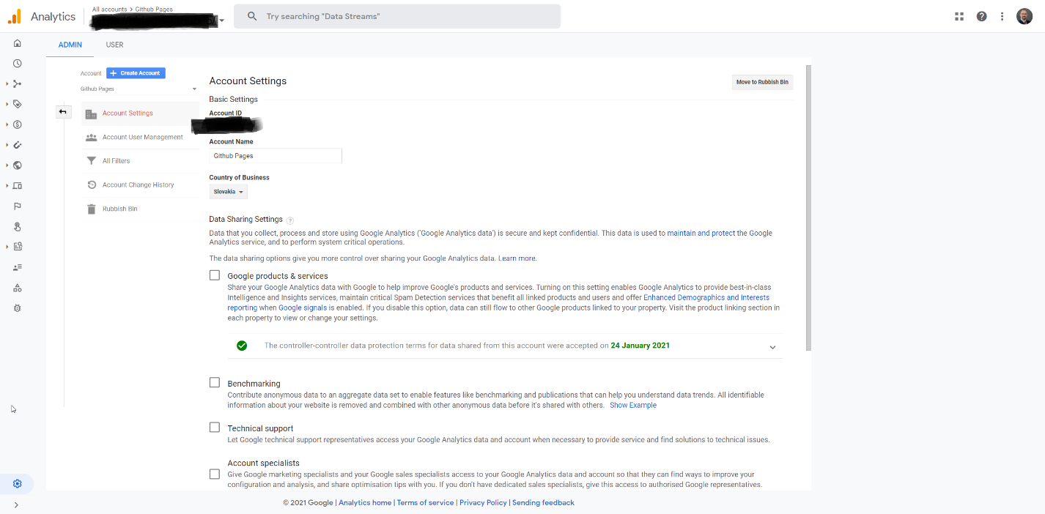

### Do not track user by ID

Inside google analytics, on the admin page, on the selected property, inside the default reporting identity set: **by device only!**

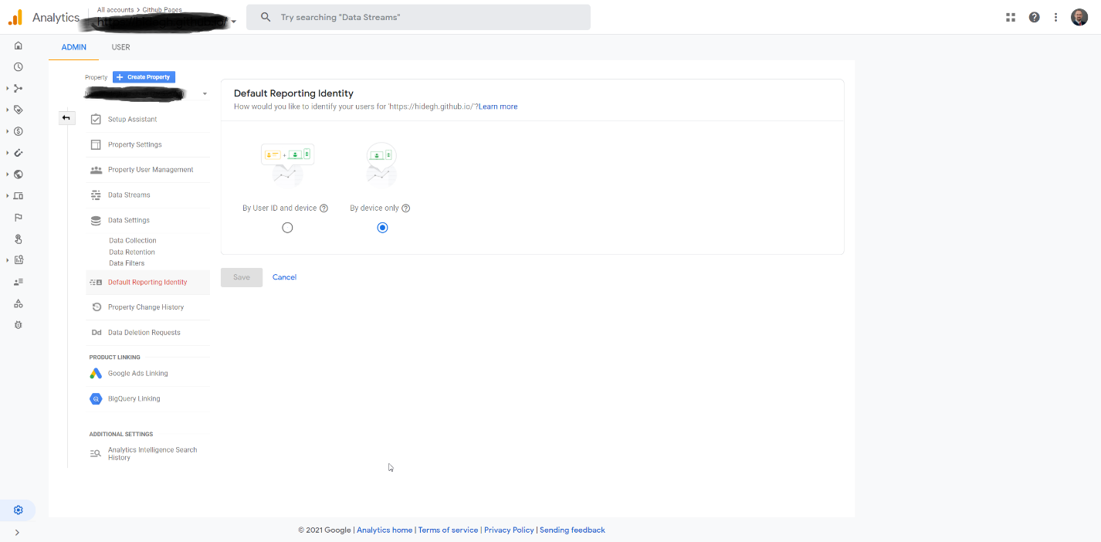

### Anonymize IP

Inside tag-manager…**add new field!**

Links: <https://www.cookieyes.com/ip-anonymization-in-google-analytics-for-gdpr-compliance/>

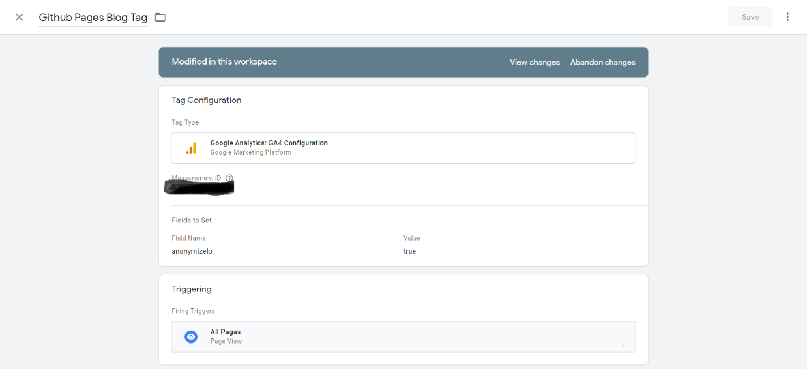

# Osano – Cookie consent – JS - Itegration

<https://www.osano.com/cookieconsent/documentation/javascript-api/>

MIT license!

There’s currently a V3 version out, the master repository contains a V4 version, but the repo and V4 has a lot of shortcomings:

* V4 has some serious **bugs** (can’t contact developers or file a ticket)
* Also V4 has a lot of **breaking changes** (but good new functions)
* <https://github.com/osano/cookieconsent/blob/dev/build/cookieconsent.min.js> **does not contains the latest build (you need to build latest version manually)**

**The idea is simple:**

* Postpone all JS loading, which might require user consent, such as:
  + Google analytics
  + Discuss and other 3rd party tools
* Make sure the consent-tool loads as first
  + It will check if user already responded, if user accepted cookies, then we should proceed with loading all the other scripts
  + If user revokes a consent, we should save this choice and reload current page

Jekyll integration sample: <https://ptc-it.de/enabling-cookie-consent-with-jekyll-minimal-mistakes/>